# Thematic seminar 1, AG1815 (2022)

|  |
| --- |
| **Group number (break out room):**  **Name:**  **Name:**  **Name:** |

## Part 1 (30 min)

1. **Preparation (5 min)**
   * Assign roles in the groups
     + 1 time keeper (make sure group keeps the time schedule)
     + 1 note taker (share screen while taking notes in this document)
     + 1 police (make sure all turn on camera and follow instructions)
   * Note taker types Group number and names in this document
   * Share your response papers (assignment that you prepared for this seminar) (send by email or by other means)
2. **Read Response papers of your two fellow group members (10 min)**
3. **Discuss Questions A & B below (15 min)**
4. **Note taker saves this document until Discussion Part 2**
5. **You will be brought back to main zoom room for a full class discussion**

|  |
| --- |
| **Question A: Revisit Lecture 2 and Lecture 3 (refers to Question 1 in Response paper)**   1. *What things did you bring up as new, interesting, or important to learn more about?* 2. *Which are important to you as individuals? Why?* 3. *Which are important to you as ICT engineers? Why?* |
| **Very brief notes from group discussion:** |

|  |
| --- |
| **Question B: ICT solutions for sustainability (refers to Question 2 in Response paper)**  *What potential trade-offs or goal conflicts did you identify for your proposed ICT solutions? Is there a risk of conflicts/trade-offs arising between different parts of a product life cycle, between different types of environmental impacts, global vs .local impacts, environmental vs. social impacts?*  *Discuss each other’s answers, make sure that you understand each other’s ideas, ask for clarifications, add new perspectives and ideas…* |
| **Very brief notes from group discussion:** |

## Part 2 (30 min)

1. **Switch roles (time keeper, note taker, police)**
2. **Read Hilty’s framework from Lecture 4 (below)**
3. **Discuss Questions 3 and 4.**
4. **Email this form to: annab@abe.kth.se**
5. **You will be brought back to main zoom room for a break and discussion**

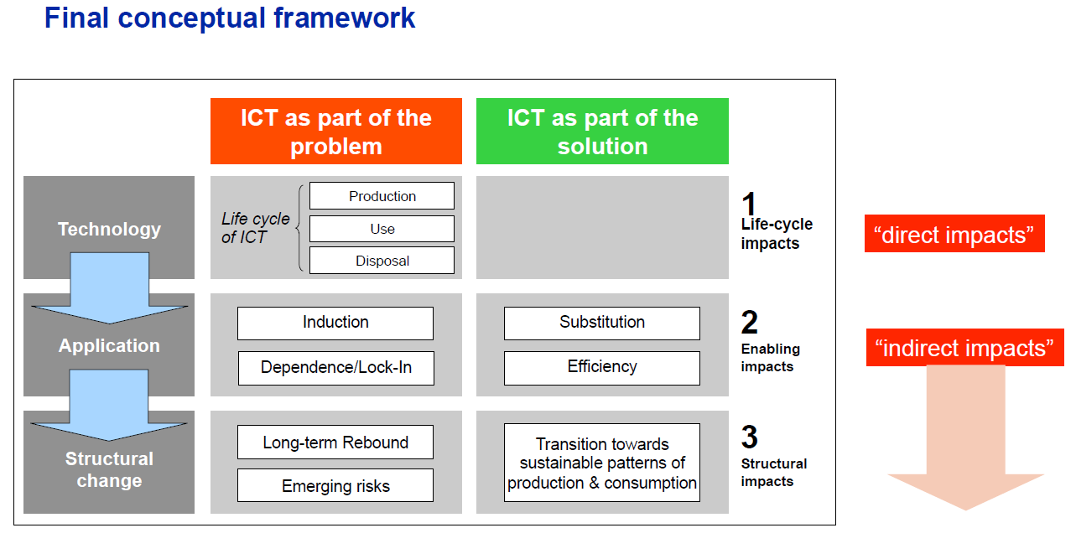

*Reference: Hilty, L.M., Aebischer, B. (2015): ICT for Sustainability: An Emerging Research Field. In: ICT Innovations for Sustainability. Advances in Intelligent Systems and Computing. Springer, 3-36,* [*https://www.tiny.uzh.ch/142*](https://www.tiny.uzh.ch/142)

**Level 1, Life cycle impacts:** Refers to the direct effects of the production, use and disposal of ICT equipment, effects that can be assessed with a Life-Cycle Assessment (LCA) approach. In particular, this includes the demand for materials and energy throughout the whole life cycle. These effects are placed entirely on the negative side as they represent the cost of providing ICT services.

**Level 2, Enabling impacts:** Refers to the enabling effects of ICT services, or the effects of applying ICT

* **Induction** **effect**: ICT stimulates the consumption of another resource (e.g., a printer stimulates the consumption of paper as it uses it faster than a typewriter).
* **Obsolescence** **effect**: ICT can shorten the useful life of another resource due to incompatibility (e.g., a device that is no longer supported by software updates is rendered obsolete).
* **Substitution** **effect**: The use of ICT replaces the use of another resource (e.g., an e-book reader can replace printed books, which is positive if it avoids the printing of a sufficiently large number of books).
* **Optimization** **effect**: The use of ICT reduces the use of another resource (e.g., less energy is used for heating in a smart home that knows where the people who live in it are located, which windows are open, what weather is forecast, etc.).

**Level 3, Structural impacts**: Refers to the systemic effects, i.e. the long-term reaction of the dynamic socio-economic system to the availability of ICT services, including behavioral change (life styles) and economic structural change.

|  |
| --- |
| **Question C: Lorentz Hilty’s conceptual framework**  *Apply the conceptual framework to one of the group’s suggested ICT solutions. Can you find examples of* ***first*** *(life cycle),* ***second*** *(enabling), and* ***third*** *(structural) order impacts?* |
| **Very brief notes from group discussion:** |

|  |
| --- |
| **Question D: Mitigating impact**  *What can be done to reduce some of the impacts identified in Question C of the suggested ICT solution, by:*   1. *Consumers?* 2. *Hardware producers?* 3. *Software developers?* |
| **Very brief notes from group discussion:** |

**Email this form to: annab@abe.kth.se**